|  |  |
| --- | --- |
| **Financial Data Intelligence**  FI526E Empirical Methods in Finance |  |
| Final Exam |  |
|  | ARDL MODEL For AMAZON and EBAY |
|  | Submitted by : Siddharth SharmaStudent no : ETU20230076 |
|  | Submitted to : Professor: Dr. Taoufik BOURAOUI |

## DATA

For the data I took stock closing prices of Amazon (AMZN) and Ebay(EBAY) because they are close competitors to each other and there is a possibility that both of the companies stock effect each other and can have a long run ARDL relationship.

The data consists of daily closing stock prices of Amazon and eBay from 29-09-23 to 28-03-24 (6 months daily 5 days a week ) with 125 observations which was supposed to be 130 observations (5 holidays due to Thanksgiving day, Christmas, New year, Martin Luther King Jr's Birthday and Presidents Day) .This missing data should not be a hindrance to the analyses of the data because the data is missing on same dates for both companies and it should not effect long run relationship.

The price is measured in USD in both stocks. Both of the data is taken From Yahoo Finance site. Also, both of the stock belongs to USA. The range (60.81001) for the Amazon stock varies from 119.57 to 180.38 and the range (14.79) of Ebay stock varies from 37.99 to 52.779999.

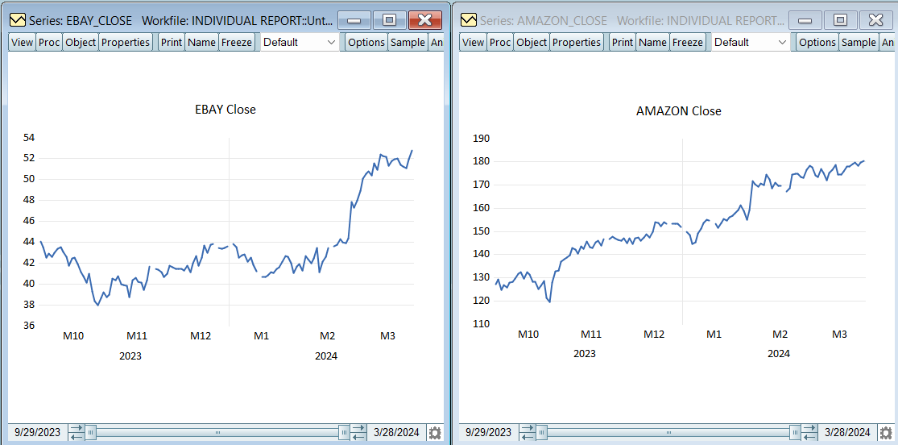

Figure 1.1 Trend analysis of both Amazon and Ebay side by side

As you can see in figure 1.1 we got to know that both AMAZON and EBAY have and upward trend in the long run so there is a possibility of a cointegration and a long run connection between the 2 Stocks. We also got to know that both the companies stock valuation is on a different scale like one is moving in the 100s and the other below 100 but it does not mean that both cannot be cointegrated this can be only found out through the test in the later steps.

## ARDL approach:

## Step 1: checking the integration order of variables AMAZON & EBAY:

Now we look at the Augmented Dickey-Fuller Unit Root Test (ADF or the Unit root test) like shown in Figure 2.2

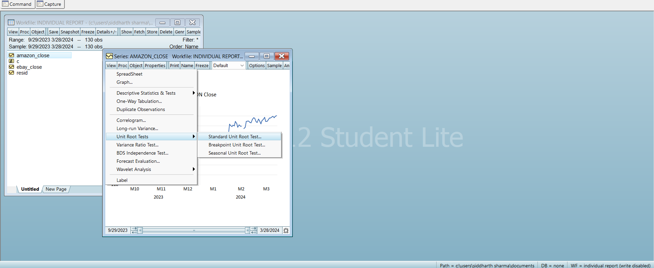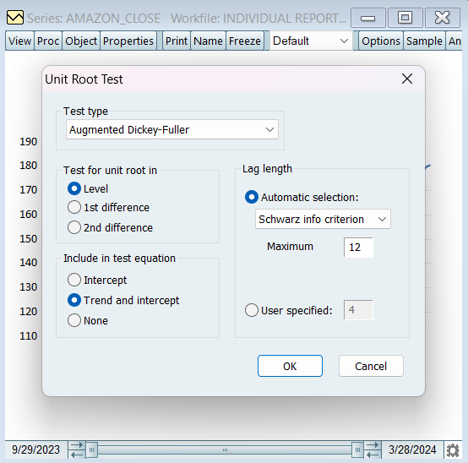

Figure 2.1 steps for performing Unit Root Test

Now we will look into Amazon in order to find its integration order :

## AMAZON

We will Start by doing the ADF at level by including both Trend and intercept and continue till we will find the significances of the last coefficient (trend for this one).

**I(0) MODEL III**

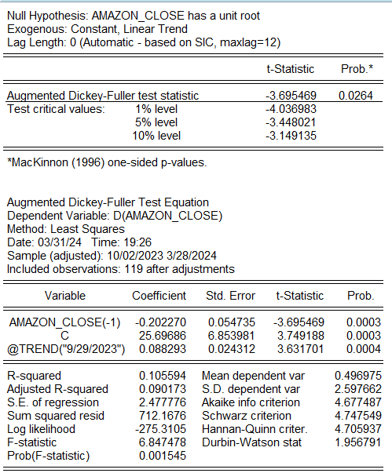



Figure 2.2 Unit Root Test for Amazon at I(0) with Trend and Intercept(Model III)

As we can see in Figure 2.2 the T-Statistic for the coefficient of the Trend of the time series (3.631701) is greater than its critical value at 5% (i.e. 2.79), We got to know that the trend is significant

Now we look at the Augmented Dickey-Fuller Test Statistic (-3.695469) which is less than the critical value for the same (-3.45) so we reject the Null Hypotheses: Amazon Close has a unit root.

Here we conclude that AMAZON_CLOSE is Significant and Stationary and is of I(0) Integration order

## EBAY

We will Start by doing the ADF at level by including both Trend and intercept and continue till we will find the significances of the last coefficient (trend for this one).

**I(0) MODEL III**

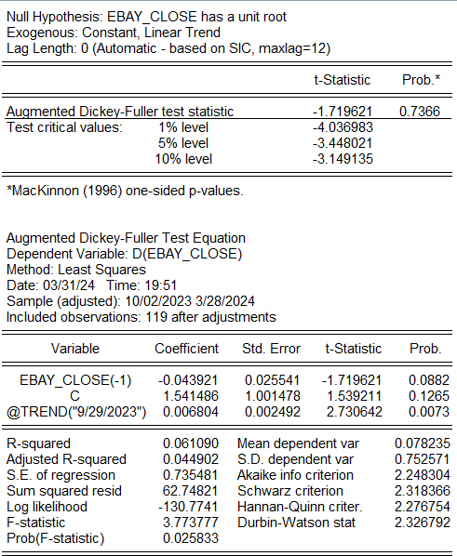



Figure 2.3 Unit Root Test for Ebay at I(0) with Trend and Intercept(Model III)

As we can see in figure 2.3 the T-Statistic of the Trend (i.e. 2.730642) is less than the critical value (i.e. 2.79),we conclude that the Trend is non significant and move to Model II for I(0) (Intercept only)

**I(0) MODEL II**

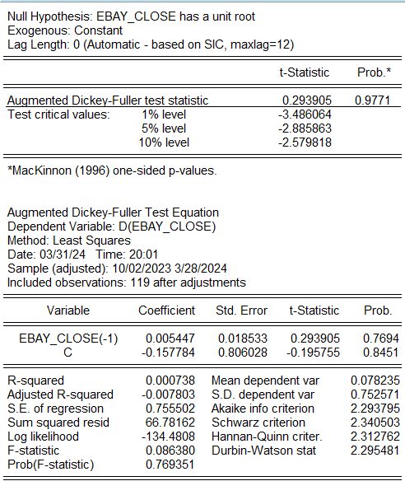



Figure 2.4 Unit Root Test for Ebay at I(0) with Intercept(Model II)

As we can see in figure 2.4 the T-Statistic of the Intercept (i.e. -0.195755) is less than the critical value (i.e. 2.54),we conclude that the Intercept is non significant and move to Model I for I(0) (no trend no intercept)

**I(0) MODEL I**

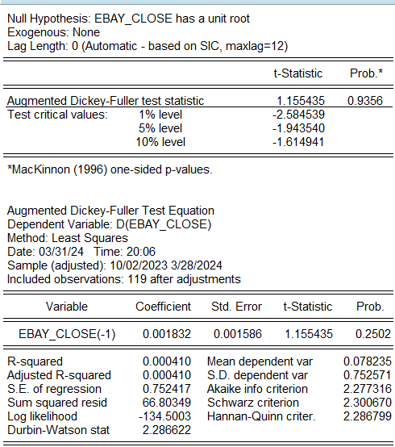



Figure 2.5 Unit Root Test for Ebay at I(0) with None(Model I)

After looking at the Figure 2.5 we know that the ADF test Statistic for the time series (i.e. 1.155435) is greater than its critical value, thus we fail to reject the null hypotheses i.e. EBAY_CLOSE has a unit root and see that the tie series is non-stationary.

Hence we move to level of 1st difference i.e. I(1)

**I(1) MODEL III**

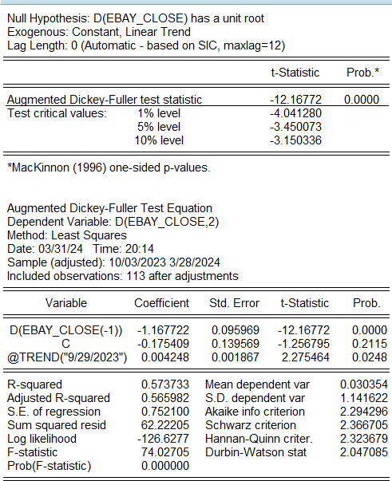

Figure 2.6 Unit Root Test for Ebay at I(1) with Trend and Intercept(Model III)

As we can see in figure 2.6 the T-Statistic of the Trend (i.e. 2.275464) is less than the critical value (i.e. 2.79),we conclude that the Trend is non significant and move to Model II for I(1) (Intercept only)

**I(1) MODEL II**

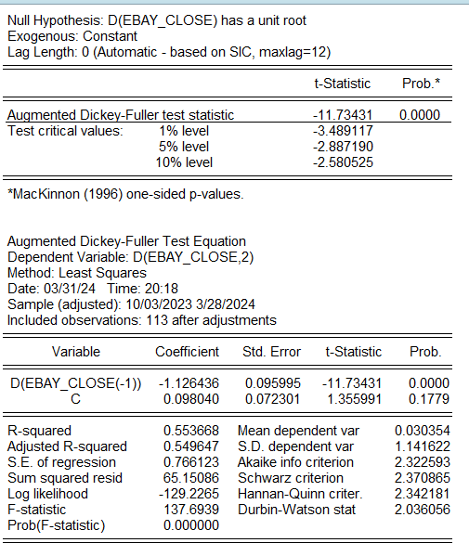

Figure 2.7 Unit Root Test for Ebay at I(1) with Intercept(Model II)

As we can see in figure 2.7 the T-Statistic of the Intercept (i.e. 1.355991) is less than the critical value (i.e. 2.54),we conclude that the Intercept is non significant and move to Model I for I(1) (no trend no intercept)

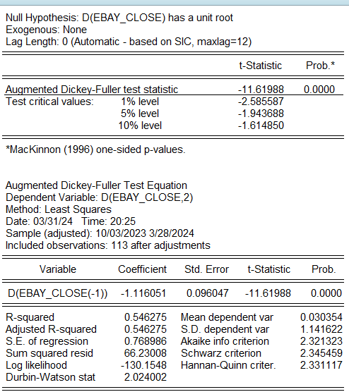

Figure 2.8 Unit Root Test for Ebay at I(1) with None(Model I)

As we look at the Adf critical value in Figure 2.8 we see that T-Statistic for the same (-11.61988) is less than its critical value (i.e. -1.943688). Finally we reject the null hypotheses and say that the time series is stationary at I(1)

Now we have a one variable at I(0) and other at I (1) now we can proceed to Step 2

## Step 2: select the Suitable lag length by estimating ARDL model with variables at level:

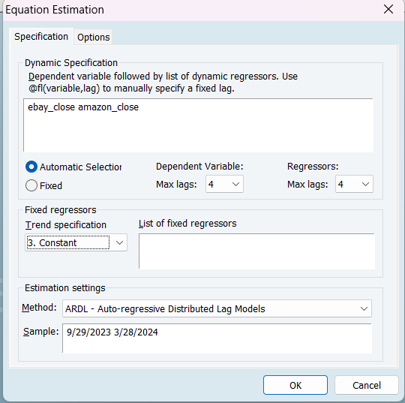

Figure 3.1 Steps for ARDL lag length

In the Step to we have to find the best lag length required Which can be done via Automatic Way as shown in the Figure 3.1 or in the manual way by comparing The AIC(Akaike info criterion) ,SC (Schwarz criterion) & HQC (Hannan Quinn criter) and taking the lowest of all and do a best out of 3 to select it.

For this, I decided to go with the Automatic selection as it will do the same thing but faster with MAX laga as (4,4).Also, in the trend Specification we will go with Restricted Constant.

In the equation EBAY_CLOSE is the dependent variable whereas AMAZON_CLOSE is the independent variable.

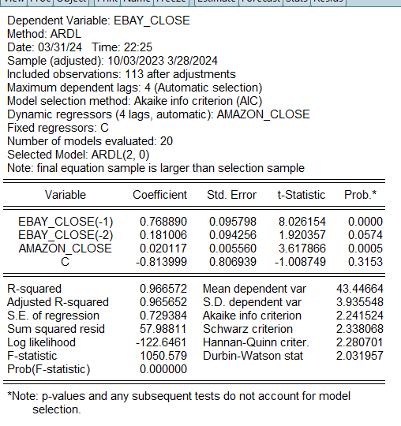

Figure 3.2 ARDL Model

As Shown in Figure 3.2 we got a Model ARDL(2,0) as the best fitted model which means that The current value of AMAZON close will effect only only the current value of the EBAY and not any future value.

Also, the EBAY’s Current values can be effected by its past 2 historical values.Here, we are taking Daily data so 2 historical values will be 2 days.

## Step 3: formulate conditional ECM:

ΔEBAY_CLOSEt = α0 + Σpi=1αi ΔEBAY_CLOSEt-i +Σqj=1bjΔAMAZON_CLOSEt-j + θ0AMAZON_CLOSEt-1 +θ1AMAZON_CLOSEt-1 + ε

After this to confirm the long run relationship we will do a Long Run Form and Bound test as shown in figure 4.1

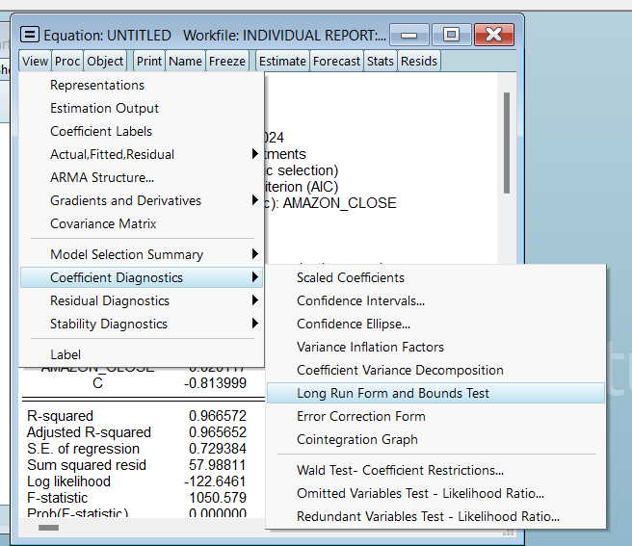

Figure 4.1

## Step 4: Bounds test:

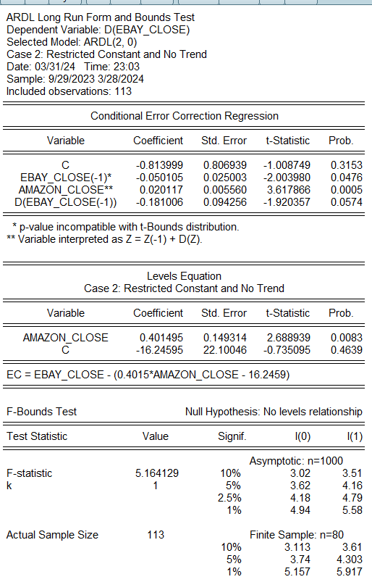

Figure 5.1 Long Run Form and Bound Test

As Shown in the Figure 5.1 the F-statistic of the test (5.164129) is greater than the I(1)(3.87) at the same level so we confirm that Amazon and Ebay have both short term and long term ARDL model as they are cointegrated. Also, the dependent Variable is now D(EBAY_CLOSE) for conditional ECM model.

Also, Z = Z(-1) + D(Z) means that it will also be used In short term equation also.

## Step 5: Estimate the long-run equilibrium & the short-run relationships between variables:

For the Long Run the Equation is given in the long run test under level equation as shown in figure 6.1

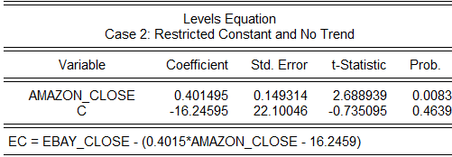

Figure 6.1

**Long Run Equation :**

EC = EBAY_CLOSE – (0.4015*AMAZON_CLOSE – 16.2459)

## Interpretation for long run

The P- value for the coefficient is less than 5 % so it is fit for long run relation

According to thew long Run equation if there is 1% increase in AMAZON_CLOSE then there will be 0.401495% increase in the EBAY_CLOSE in the long run

Now we will calculate the ECM model for the short run equations as shown in the Figure 6.2 .

The short run equation can be given by:

ΔEBAY_CLOSEt = α0 +α1ΔEBAY_CLOSEt-1 + b0ΔAMAZON_CLOSEt +λet-1 +εt

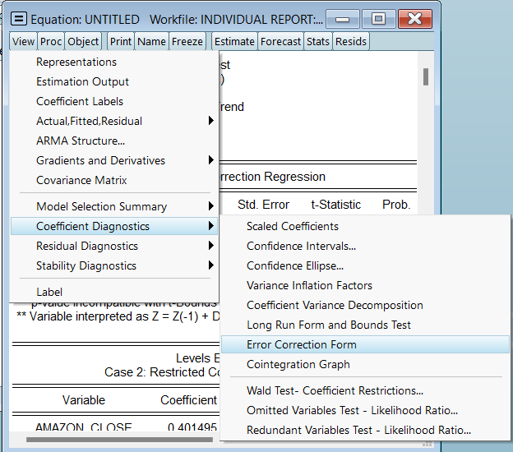

Figure 6.2 Steps for ECM

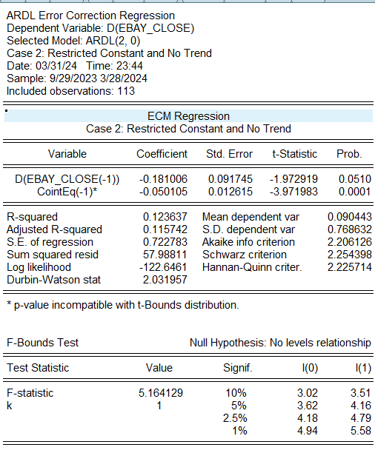

Figure 6.3 ECM

**Short run equation:**

ΔEBAY_CLOSEt = -0.181*ΔEBAY_CLOSEt-1 + 0.020*ΔAMAZON_CLOSEt -0.0501et-1 +ε

## Interpretation :

According to this error correction model the cointegration equation CointEq(-1) is negative and p-value is less than 0.05 which means that there is long run causality present.

Here the CointEq(-1) means the speed of adjustment of any equilibrium towards long run equilibrium rate

Here the speed of adjustment is 0.050*100 = 5%, so the speed of adjustment is very slow. This also indicate that the gap between the 2 different equilibrium is nullified within a day (as it is daily Data). The coefficient of (D(EBAY_CLOSE(-1)) ) suggests that past values of eBay’s closing price have a negative relationship with the current price change in the short run. Also, D(AMAZON_CLOSE) has a positive relationship with the current price change of EBAY.

|  |  |  |
| --- | --- | --- |
| Date DATA IN TABLE FORMAT | AMAZON_CLOSE | EBAY_CLOSE |
| 29-09-2023 | 127.12 | 44.09 |
| 02-10-2023 | 129.46 | 43.55 |
| 03-10-2023 | 124.72 | 42.51 |
| 04-10-2023 | 127 | 42.94 |
| 05-10-2023 | 125.96 | 42.61 |
| 06-10-2023 | 127.96 | 43.01 |
| 09-10-2023 | 128.26 | 43.35 |
| 10-10-2023 | 129.48 | 43.52 |
| 11-10-2023 | 131.83 | 43.05 |
| 12-10-2023 | 132.33 | 42.63 |
| 13-10-2023 | 129.79 | 41.79 |
| 16-10-2023 | 132.55 | 42.47 |
| 17-10-2023 | 131.47 | 42.56 |
| 18-10-2023 | 128.13 | 41.89 |
| 19-10-2023 | 128.4 | 41.14 |
| 20-10-2023 | 125.17 | 40.76 |
| 23-10-2023 | 126.56 | 40.17 |
| 24-10-2023 | 128.56 | 40.99 |
| 25-10-2023 | 121.39 | 39.3 |
| 26-10-2023 | 119.57 | 38.36 |
| 27-10-2023 | 127.74 | 37.99 |
| 30-10-2023 | 132.71 | 38.64 |
| 31-10-2023 | 133.09 | 39.23 |
| 01-11-2023 | 137 | 38.71 |
| 02-11-2023 | 138.07 | 38.99 |
| 03-11-2023 | 138.6 | 40.54 |
| 06-11-2023 | 139.74 | 40.36 |
| 07-11-2023 | 142.71 | 40.77 |
| 08-11-2023 | 142.08 | 39.95 |
| 09-11-2023 | 140.6 | 39.93 |
| 10-11-2023 | 143.56 | 39.85 |
| 13-11-2023 | 142.59 | 38.73 |
| 14-11-2023 | 145.8 | 40.34 |
| 15-11-2023 | 143.2 | 40.62 |
| 16-11-2023 | 142.83 | 40.18 |
| 17-11-2023 | 145.18 | 40.14 |
| 20-11-2023 | 146.13 | 39.45 |
| 21-11-2023 | 143.9 | 40.39 |
| 22-11-2023 | 146.71 | 41.64 |
| 24-11-2023 | 146.74 | 41.48 |
| 27-11-2023 | 147.73 | 41.35 |
| 28-11-2023 | 147.03 | 41.13 |
| 29-11-2023 | 146.32 | 40.64 |
| 30-11-2023 | 146.09 | 41.01 |
| 01-12-2023 | 147.03 | 41.73 |
| 04-12-2023 | 144.84 | 41.62 |
| 05-12-2023 | 146.88 | 41.48 |
| 06-12-2023 | 144.52 | 41.47 |
| 07-12-2023 | 146.88 | 41.48 |
| 08-12-2023 | 147.42 | 41.29 |
| 11-12-2023 | 145.89 | 41.76 |
| 12-12-2023 | 147.48 | 41.11 |
| 13-12-2023 | 148.84 | 41.96 |
| 14-12-2023 | 147.42 | 42.65 |
| 15-12-2023 | 149.97 | 41.75 |
| 18-12-2023 | 154.07 | 42.52 |
| 19-12-2023 | 153.79 | 43.67 |
| 20-12-2023 | 152.12 | 42.98 |
| 21-12-2023 | 153.84 | 43.73 |
| 22-12-2023 | 153.42 | 43.82 |
| 26-12-2023 | 153.41 | 43.48 |
| 27-12-2023 | 153.34 | 43.38 |
| 28-12-2023 | 153.38 | 43.47 |
| 29-12-2023 | 151.94 | 43.62 |
| 02-01-2024 | 149.93 | 43.87 |
| 03-01-2024 | 148.47 | 43.55 |
| 04-01-2024 | 144.57 | 42.53 |
| 05-01-2024 | 145.24 | 42.79 |
| 08-01-2024 | 149.1 | 42.84 |
| 09-01-2024 | 151.37 | 42.14 |
| 10-01-2024 | 153.73 | 42.56 |
| 11-01-2024 | 155.18 | 41.87 |
| 12-01-2024 | 154.62 | 41.21 |
| 16-01-2024 | 153.16 | 40.7 |
| 17-01-2024 | 151.71 | 40.67 |
| 18-01-2024 | 153.5 | 40.79 |
| 19-01-2024 | 155.34 | 41.13 |
| 22-01-2024 | 154.78 | 41.06 |
| 23-01-2024 | 156.02 | 41.41 |
| 24-01-2024 | 156.87 | 41.61 |
| 25-01-2024 | 157.75 | 42.16 |
| 26-01-2024 | 159.12 | 42.69 |
| 29-01-2024 | 161.26 | 42.62 |
| 30-01-2024 | 159 | 41.95 |
| 31-01-2024 | 155.2 | 41.07 |
| 01-02-2024 | 159.28 | 41.7 |
| 02-02-2024 | 171.81 | 41.94 |
| 05-02-2024 | 170.31 | 41.33 |
| 06-02-2024 | 169.15 | 42.66 |
| 07-02-2024 | 170.53 | 42.34 |
| 08-02-2024 | 169.84 | 42.02 |
| 09-02-2024 | 174.45 | 42.43 |
| 12-02-2024 | 172.34 | 43.49 |
| 13-02-2024 | 168.64 | 41.13 |
| 14-02-2024 | 170.98 | 42.18 |
| 15-02-2024 | 169.8 | 42.62 |
| 16-02-2024 | 169.51 | 43.45 |
| 20-02-2024 | 167.08 | 43.59 |
| 21-02-2024 | 168.59 | 43.8 |
| 22-02-2024 | 174.58 | 44.28 |
| 23-02-2024 | 174.99 | 44.01 |
| 26-02-2024 | 174.73 | 43.88 |
| 27-02-2024 | 173.54 | 44.39 |
| 28-02-2024 | 173.16 | 47.89 |
| 29-02-2024 | 176.76 | 47.28 |
| 01-03-2024 | 178.22 | 48.05 |
| 04-03-2024 | 177.58 | 48.91 |
| 05-03-2024 | 174.12 | 50.09 |
| 06-03-2024 | 173.51 | 50.54 |
| 07-03-2024 | 176.82 | 50.78 |
| 08-03-2024 | 175.35 | 50.37 |
| 11-03-2024 | 171.96 | 51.55 |
| 12-03-2024 | 175.39 | 50.91 |
| 13-03-2024 | 176.56 | 52.41 |
| 14-03-2024 | 178.75 | 52.25 |
| 15-03-2024 | 174.42 | 52.2 |
| 18-03-2024 | 174.48 | 51.35 |
| 19-03-2024 | 175.9 | 51.82 |
| 20-03-2024 | 178.15 | 51.97 |
| 21-03-2024 | 178.15 | 52 |
| 22-03-2024 | 178.87 | 51.42 |
| 25-03-2024 | 179.71 | 51.23 |
| 26-03-2024 | 178.3 | 51.08 |
| 27-03-2024 | 179.83 | 51.92 |
| 28-03-2024 | 180.38 | 52.78 |